避免將password直接寫在domain.xml
- Create password alias:
asadmin create-password-alias db_pw_acctmgmt: 建立alias 為db_pw_acctmgmt的password alias.
asadmin update-password-alias db_pw_account: 修改alias為db_pw_acctmgmt的password alias.
Asadmin delete-password-alias db_pw_acctmgmt: 刪除 alias為db_pw_acctmgmt的password alias.
asadmin list-password-aliases: 顯示目前domain內所有的password aliases.
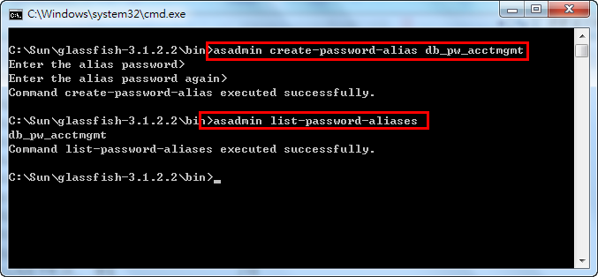
所以建立的password alias會以加密的方式存放在 <domain folder>\config\domain-passwords

- change domain.xml
<jdbc-connection-pool driver-classname="" datasource-classname="com.microsoft.sqlserver.jdbc.SQLServerDataSource" res-type="javax.sql.DataSource" name="acctmgmtPool">
<property name="User" value="acctmgmt_user"></property>
<property name="Password" value="${ALIAS=db_pw_acctmgmt}"></property>
<property name="URL" value="jdbc:sqlserver://192.168.2.92:1433;databaseName=ACCTMGMT"></property>
</jdbc-connection-pool>

- Reference:
http://docs.oracle.com/cd/E18930_01/html/821-2435/ghgrp.html#ghgqc

